EMERGENCY PLANNING
Body Corporate X and Management require that during every emergency an organized effort be made to protect employees, residents and visitors from further injury and to minimize property damage. The Master Emergency Action Plan shall be constantly evaluated to make sure all changes in operations and hazards are accounted for. It is imperative that all Employees and Contractors are informed of the procedure to follow in the event of the emergency.
In this context, a major emergency may be one of the following:
- major damage or potential major damages to buildings or structures;
- an emergency that involves more than one building or facility;
- a potential hazard to the surrounding community;
- threats, civil disturbances or alerts;
- natural disasters such as hurricanes, earthquakes, floods, and landslides;
- wide spread electrical power or other utility failures.

During response to such major events, if deemed necessary, Fire or Police shall be immediately summoned by dialing 000.

Master Emergency Evacuation Plan

(Insert Building Layout showing Assembly Area and travel Routes)

FIRE SAFETY TRAINING MANUAL

What is an Emergency?

An emergency is any event that arises internally or from external resources, which may adversely affect persons or the community that requires an immediate response (AS3745:2002).

Types of emergencies are usually defined by existing hazards based on the type of work and environment. Some of the more common emergencies include:

- Electrical hazard
- Fire
- Flooding
- Hazardous material spill.
- Gas leak (natural gas or liquefied petroleum gas (LPG) explosion)
- Bomb threat

What is a hazard?

A hazard can be described as any circumstance, material or site which has the potential to cause injury or illness. Hazards may include:

- Fire doors jammed open or blocked
- Chemicals
- Unsafe behaviour
- Poor work design
- Inadequate management systems (for example, no procedures for performing tasks safely)
- Unprotected openings, sharp edges, unsafe electrical wiring
- Manufacturing processes, such as those which involve heat or chemicals
- Exposed heat or electrical sources

If an unsafe practice or situation comes to your attention:

- Make sure that you do not become a part of the problem
- Avoid the area or activity and stay clear of the problem until you have checked it out thoroughly
- Decide whether or not you will be able to correct the problem
- Follow workplace reporting procedures

House Keeping

Reducing hazards and improving the safety of the building is a basic requirement of good practice housekeeping. Following are some guidelines to ensure the health of safety of all persons in the building:
- Ensure that repairs and services are carried out by authorized personnel only
- Maintain security inspections and lock up areas after use
- Keep the building clean and mop up spills immediately
- If applicable change batteries in smoke detectors annually
- Keep all safety signs clean and in clear view
- Avoid running multiple leads from a single power plug
- Clean built up residue from around machinery
- Keep hallways, corridors and exits clear of stored items
- Check equipment and stocks of goods regularly for deterioration in performance or signs of corrosion or leaks
- Use only approved replacement parts
- Store cylinders and containers appropriately
- Ensure that safety signs indicate all dangerous areas or activities
- Replace worn power leads and have them inspected annually
- Follow all instructions on equipment and machinery
- Do not store flammable goods under stairways and exits
- Store flammable liquids in approved containers or cabinets
- Keep curtains, towels and fabrics clear of heating or cooking appliances
- Do not hang materials near naked flames or cook tops

Human Behaviour in an Emergency

During an emergency situation you may be the person responsible for the possible evacuation and movement of people. This may be a great time of stress and uncertainly for everyone, it’s therefore important to understand how people may react when they encounter an emergency as you may need to know how to deal with people under stress.

The types of behaviours in an emergency situation are quite varied and could be any of the following:

- Freezing
- Panic reactions
- Orderly behaviour
- Taking initiative to help even though it is unwanted
- Managers or senior authorities attempting to take charge despite not being the nominated person responsible

Methods available to reduce stress or fear

- Ensuring that the Evacuation Coordinator is easily identifiable through use of hard hat, symbol or sign of authority
- Remain calm and composed
- Use clear, concise sentences and speak with authority
- Ensure evacuation procedures are carried out regularly to create a sense of familiarity
- Ensure personnel are regularly and appropriately trained to carry out procedures and use of equipment

Types of Emergencies

To determine the types of emergencies, it is recommended that a risk assessment be conducted for your building. As a general guide, the following emergencies are most likely to occur:

- Fire
- Civil disturbance
- Medical
- Armed intrusion
- Suspicious packages
- Bomb threats
- Power failure or blackout
- Building damage
- Air –conditioning contamination
- Hazardous material spills

Responsible Persons

The number of persons responsible for evacuating people in an emergency situation is dependent on the size and structure of the workplace or building. The appointment of an Evacuation Coordinator will facilitate the safe evacuation of persons in an emergency. It is recommended assistants are appointed to help evacuate persons with medical conditions. In structured workplaces the primary purpose of an Emergency Control Organisation (ECO) is to ensure that life safety takes precedence over asset protection. The secondary role is to prevent emergencies from occurring, prepare for emergencies and to restore the workplace to normal functioning after an emergency. The role for each of the persons is reflected in the responsibilities, duties and authority given to persons of the ECO.

Structure of an ECO

Chief Fire
Warden
Area Warden
Area Warden

Area Warden

Warden

Warden

Area Warden

Warden

Warden

Warden

Warden

Warden

Warden

First Aid

Identification of ECO people

ECO members are identified through the use of different colours. The colours can appear in the form of a helmet, cap, vest or arm band. The following colours are used:

Position | Colour
Chief Warden | White
Floor or Area Warden | Yellow
Warden | Red
First Aid Representative | Green

Roles and Responsibilities

Chief Warden
On becoming aware of an emergency, the Chief Warden shall take the following actions:

- Ensure that the building is safe (turn off heat generating equipment)
- Proceed to a central control point
- Ascertain the nature of the emergency and determine the appropriate action
- Ensure that the appropriate service has been notified
- Ensure floor/area wardens have been advised of the situation
- If necessary initiate evacuation and control entry to affected areas

Post initial response actions:
- Any progress or action taken is recorded in an incident log book
- Brief the emergency personnel upon arriving on the type, scope and location of emergency

When there are no emergencies the Chief Warden, Deputy Chief Warden and Communications officer are involved in:

- Participation at emergency planning committee meetings
- Co-ordination of emergency planning, training and evacuation drills
- Liaison with emergency services
- Liaison with the Fire Safety Adviser/Workplace Health and Safety Officer to identify and rectify any workplace hazards

Deputies and Assistants
Appointed to ensure continuity of functions during the absences of any persons of the ECO

Communications Officer (If applicable)

- Ascertain the nature and location of the emergency
- Confirm that the appropriate emergency service has been notified
- Notify the appropriate ECO personnel by an emergency warning call or by other means
- Transmit and record instructions and information between the Chief Warden and the floor wardens and occupants
- Maintain a log of the events as directed by the Chief Warden

Floor or Area Wardens

On hearing an alarm or becoming aware of an emergency, the following actions should be taken:

- Implement the emergency procedures for their floor or area
- Ensure that the appropriate emergency service has been notified
- Direct Wardens to check the floor or area for any abnormal situation
- Commence evacuation if the circumstances on their floor or area warrant the need

Post initial response actions:
- Communicate with the Chief Warden by whatever means available and act on instructions
- Advise the Chief Warden as soon as possible of the circumstances and action taken
- Identify persons to assist Wardens during an emergency
- Confirm that activities have been completed and report this to the Chief Warden

When there are no emergencies the Floor or Area Wardens are involved in:

- Participation at emergency planning committee meetings
- Emergency planning, training and evacuation drills
- Liaison with the WHSO to identify and rectify any workplace hazards

Wardens

Floor Wardens may be required to carry out a number of different activities including but not limited to:

- Act as Floor or Area Wardens
- Ensure that the appropriate emergency service has been notified
- Check to ensure fire and smoke doors are properly closed if applicable
- Orderly flow of persons into protected areas

Post initial response actions:

- Search the floor to ensure all persons have evacuated
- use the back of your hand to check closed doors before entering offices and rooms (don’t just call out)
- check toilets, store rooms, meeting rooms, board rooms, etc

Occupants/Employees

During emergency situation occupants have the responsibility of:

- Following the instructions of the Evacuation Co-ordinator or in the case of structured workplace the ECO
- Being aware of emergency procedures for your area
- Recognising alert and alarm signals
- Knowing the location of portable fire safety equipment, safe designated exit signs and location of assembly area
- Identifying and report potential emergencies
- Participating in training and evacuation exercises

Options in an Emergency

Evacuation
An evacuation is ordered by an Evacuation Coordinator when it is determined life threatening if the occupants were to remain in the workplace or building. Evacuations are ordered for the following types of emergencies:

- Fire
- Bomb threat (An alternative assembly area)
- Biological or radiological threat
- Hazardous material spills
- Air – conditioning contamination
- Power failure or blackout
- Building damage

Lock down
This method is used to protect occupants from internal or external threat. Wardens may be directed to lock entrances and routes to deter admission to the workplace. Example: armed intrusion. Lock-down must be communicated verbally or by any means available other than the emergency evacuation tones/alarms

Shelter-in-place
This method protects occupants within the buildings without locking the workplace. This is implemented when there is no immediate danger to the structure of the building. This is communicated by using appropriate means relative to the emergency or threat. Evacuation is likely to expose persons to more danger. Examples: fire in the adjacent property, a flood or a hazardous spill in the adjacent property

Do nothing
This is self explanatory. This means that there may be an emergency but there is no risk to persons. Wardens may be required to alert staff and brief them on the emergency

First Attack Procedures
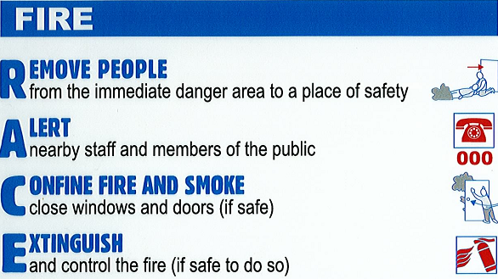

Evacuation

STAGE 1: REMOVAL OF PEOPLE FROM THE IMMEDIATE DANGER AREA
Employees, Occupiers or Members of the public in the immediate danger area, are to evacuate to a place of safety. When the area has been evacuated, doors should be closed to localise the fire.

STAGE 2: COMPLETE EVACUATION OF THE ENTIRE COMPLEX
Should the emergency necessitate evacuation of the entire complex, employees will assemble at the assembly points and remain there until otherwise directed.

STAGE 3: ROLL CALL
To be conducted as soon as possible to ensure all occupants are accounted for. Report missing persons to the attending FIRE OFFICERS

STAGE 4: ASSEMBLY AREAS
The assembly area as indicated on the site plan.

STAGE 1: REMOVAL OF PEOPLE FROM THE IMMEDIATE DANGER AREA
- Remove any persons in immediate danger if it is safe to do so
- First priority is to notify the Evacuation Coordinator or Chief Warden of the emergency and warn people in immediate danger
- Fire/Emergency Service Called
- Confine - The situation needs to be isolated to as small an area as possible
- Consult – The Emergency response team or persons needs to report to the Evacuation Coordinator or Chief Warden with specific information in relation to the emergency situation. Additional advice may need to be sought by professionals
- Decide on Action - Now is the time to decide if you attempt to control the emergency situation. Before deciding to control the situation consider the following:
- Support: You should ensure that someone knows what you are attempting to do
- Size: Incidents that are beyond your capability should be left to experienced emergency organisations
- Surroundings: Check surroundings for any signs of danger such as gas cylinders, sealed containers or physical hazards which impede escape routes
- Smoke/Gas/Vapour/Fumes: Avoid entering an environment where smoke is limiting visibility even at low levels in the room
  - Select the correct equipment
  - Control the incident
- Test Equipment: Make sure it works
- PPE: Use the appropriate Personal Protective Equipment
- Be Vigilant: Don’t turn away from the incident even it appears contained
- Confine: If the incident cannot be controlled, evacuate.

STAGE 2: COMPLETE EVACUATION OF THE ENTIRE COMPLEX
- Brief Assistants or Wardens on the nature/scale of the emergency and plan of action
- Advise the safest path of egress and assembly area
- Evacuate the emergency affected area, then commence staged evacuation until all persons have left the building (if necessary)
- Ensure all rooms, areas and toilets are checked
- Assess mobility of clients to determine the order of evacuation
- Delegate duties as appropriate
- Evacuate the premises

STAGE 3: ROLL CALL
- Roll call conducted as soon a possible to account for all persons

STAGE 4: ASSEMBLY AREAS
- Ensure assembly areas are clear of entry points to provide access for emergency services
- Accessible
- If possible not in car parks
This may be changed depending on the nature and location of the emergency (Determined by the Evacuation Coordinator or Chief Warden)

Evacuation Considerations

Order of evacuating personnel
- Ambulant people who can walk first
- Semi ambulant people who can walk with assistance
- Non – ambulant people who cannot walk

Non ambulant people should be assisted to a safe place. The person nominated to assist can be pre-designated although that person’s availability must be considered. In the event of an emergency, a nominated person will be assigned the responsibility of ensuring the safety of non ambulant persons.

Refusal to evacuate

At no time are Wardens, Occupants, Evacuation Coordinator, security or persons other than Emergency Service Personnel to use physical force to remove someone who refuses to evacuate. Touching, poking or slapping a person who seems to be in a state of extreme fear or shock may cause a violent reaction and is considered assault

- Wardens should ask the person to evacuate,
- If they refuse, ask them again attempting to gently persuade them to evacuate
- If they still refuse, continue with your duties and when finished report the location of person to the Warden/Area Warden and Chief Warden
- No-one other than Emergency Services shall re enter to remove the person

Unconscious person

- Should be removed from immediate danger where safe
- Given first aid if safe to do so
- Their medical state and location notified to the Chief Warden/Evacuation Coordinator

Locked area or room

- An attempt should be made to determine if there is any person in the room
- Feel the door with the back of hand to determine if there is fire on the other side
- If there is no warmth and it is safe to do so, open the door
- If locked, knock loudly and shout to determine if anyone is inside
- If no response then inform the Warden/Area Warden/Chief Warden and let them know you could not determine whether there was anyone inside

Bomb Threats

There are 3 types of bomb threats:

- Written threats
- Telephone threats
- Suspect object

Written threats

  - Keep the note and any envelope or packaging
  - Avoid unnecessary handling to retain evidence
  - Place evidence in an envelope if possible (preferable plastic)
  - Do not alert everyone of the threat
  - Advise the Chief Warden/Evacuation Co-ordinator or supervisor
  - Contact the police

Telephone threats

- Treat as genuine
- Do not hang up
- Obtain as much information as possible
- Complete bomb threat checklist ( See Attachment)
- Do not alert everyone of the threat
- Advise your Chief Warden/Evacuation Co-ordinator or Supervisor
- Contact the police

Suspect objects

- Identified by an employee as suspect by virtue of its characteristics, location and circumstances
- Advise your Chief Warden/Evacuation Coordinator or Supervisor
- Contact the police

Assembly Point

Site plans should be located at emergency exits clearly identifying assembly points. When ordered to do so (by alarm, Evacuation Coordinator or Warden) you should evacuate in an orderly fashion and should not try to obtain substantial amount of personal belongings. While at the assembly point, the presence of persons should be recorded by the Evacuation Coordinator or Warden and any missing persons reported to the Emergency Services. Emergency Services will conduct a search and if persons are not found they will officially be reported as missing. It is essential that a role call procedure is taken seriously to avoid wasting time and putting Emergency Services Personnel in danger. Persons should not disperse from the assembly point until told to do so. In the case of an emergency where the designated assembly point may put persons in danger, a secondary assembly point will be identified and persons will be ordered to proceed to this assembly point.

First Attack Fire Fighting

Controlling fires using fire equipment may be required in an emergency situation. In an emergency you may find yourself using fire extinguishers, hose reels or extinguishers. See Appendix 2 – How to use a fire extinguisher.

Characteristics of fire

- Fire is a chemical reaction that gives off large amounts of heat and light
- This chemical reaction takes place between fuel which is any substance that can burn and an oxidiser, (usually oxygen, which is a gas that makes up about 21% of the air we breathe)
- The chemical reaction of fire is started and kept going by the presence of enough heat
- Once started, a fire may produce enough of its own heat to keep burning until all the available fuel and/or oxidiser is used

Classes of Fire
Class A
Common, solid fuels with an organic carbon base, such as wood, paper, fabric, plaster and rubber. Extinguish by cooling with water.
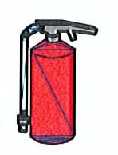or 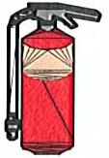or 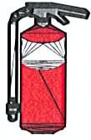or 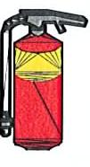
Class B
Fires involving flammable and combustible liquids such as petrol, oil, alcohol, kerosene, paint, methylated spirits and wax.
Extinguish by smothering or Inhibiting with foam.
or 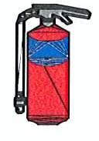or or or
Class C
Fires involving flammable gases, such as natural gas, LP Gas, hydrogen and acetylene. Best extinguished by starving the fire of the gas supply e.g. by turning off the supply.
Class D
Fires involving combustible metals, such as magnesium or aluminium shavings. These need special smothering methods to extinguish them. If water is applied to a Class D fire it will break down into its elements, hydrogen and oxygen and accelerate combustion or cause an explosion. It may be wise to let metal burn out if there are no exposures or other risks.
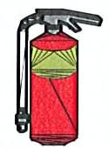
Class E
Electricity is not a fuel and it does not burn like a fuel. However, it is a dangerous complication at a fire, because it is a source of heat & potential electric shock. Electricity can cause additional problems in structure fires as adding water increases the risk of an electrocution. Appliances likely to cause electrical fires include driers toasters stoves jugs irons clothes driers, toasters, stoves, electrical jugs, irons, electric motors. Fires involving electricity are normally best extinguished by smothering or inhibiting, but only with a substance that is a non-conductor of electricity. Once an electrical supply has been shut off, a fire can be attacked according to the type of fuel that is burning. Small electrical fires can be attacked with an extinguisher containing a non-conducting firefighting agent.
Extinguishers safe to use on electrical fires may have an (E) printed inside brackets on their label.
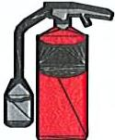or or
Class F
Fires involving combustible fats and oils, such as those found in food deep fryers. Commonly encountered in restaurants and commercial kitchens. These fires should be smothered using the appropriate extinguishing agent. Special ‘wet’ chemical extinguishers may be installed in commercial kitchens

or

Classification | Fire Types | Extinguishers used
Class A | Wood, paper, textiles, rubber and most plastics | Water, Wet Chemical. Foam, Dry Chemical Powder (DCP), Vaporising Liquid, Fire Blanket
Class B | Oils, petrol, paints, thinners | Foam, DCP, Carbon Dioxide (Co2), Vapourising Liquid, Fire Blanket
Class C | LP Gases and industrial gases e.g. Acetylene | DCP
Class D | Used for rare metal types | Metalex
Class E | Electrically energised fuels of any other class | DCP, Co2, Vapourising Liquid
Class F | Cooking oils and animal fats | Wet Chemical, Foam, Co2, Fire Blanket

RACE Procedure

How to use a fire extinguisher

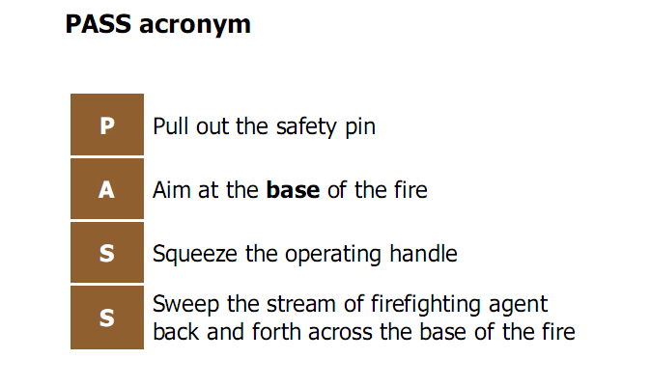
How to use a Fire Hose Reel

