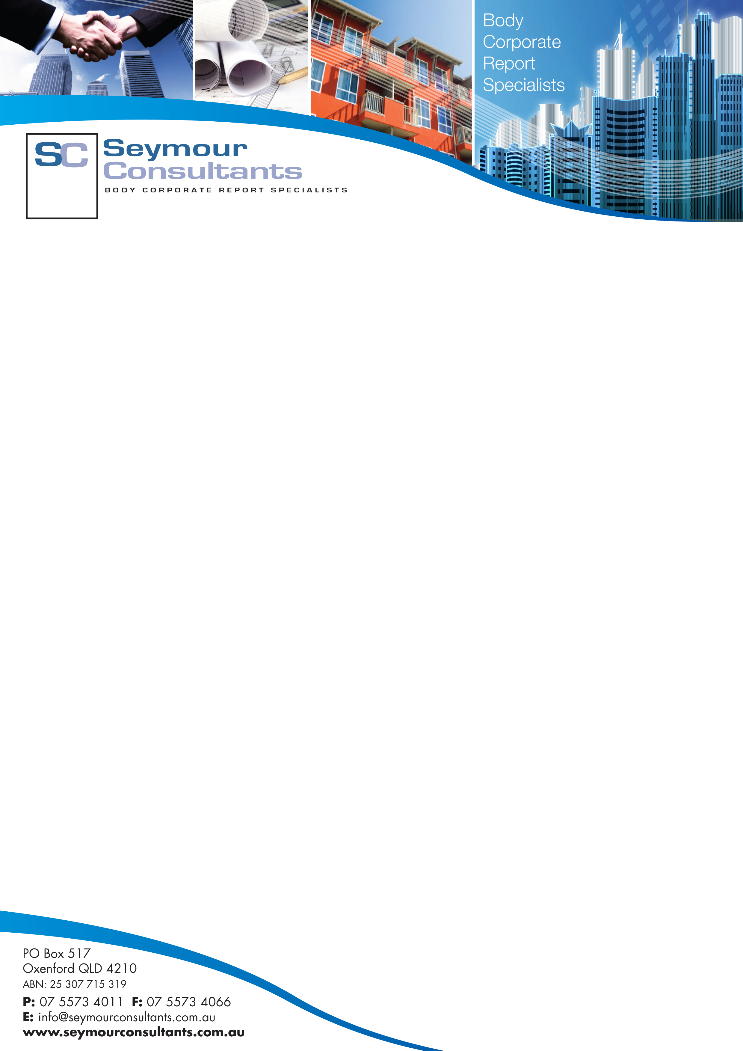

WORK HEALTH AND SAFETY MANUAL
FOR BODY CORPORATE XXXX CTS
ADDRESS
CITY, STATE, POST CODE
PREPARED BY SEYMOUR CONSULTANTS PTY LTD

